02 Clinical Lab Tests

|  |  |
| --- | --- |
| Heart Rate | 60-100 beats/min |
| Respiratory Rate | 12-18 respirations/min |
| BP | Systolic Diastolic  Normal 120 80  Prehypertension +20 = 140 +10 = 90  Stage 1 hypertnt +20 = 160 + 10 = 100  Stage 2 hypertnt >160 >100 |
| Temp | Oral 98.6° F |
| IBW (ideal body weight) | IBW male = 50 + (2.3)(height in inches >60)  IBW female = 45 + (2.3)(height in inches >60) |
| BMI (body mass index) | BMI = (weight kg)/(height m^2)  Obese if BMI > 30 |
| Gestational Age | 8 months = 40 weeks (+- 2 weeks) |

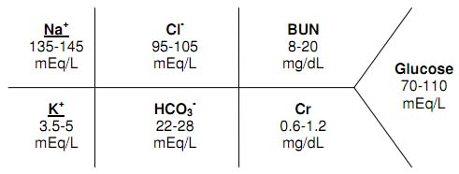

Na

K

Cl

COs COs

BUN

Cr

Glucose

|  |  |
| --- | --- |
| N**a** | 135 – 145 mEq/L 140 (+- 5) |
| C**l** | 95 – 105 mEq/L 100 (+- 5) |
| BUN | 8 – 20 mg/dL 15 (+-5) |
| K (**P**otassium) | 3.5 – 5 mEq/L 4 (+- 1) |
| Plasma **CO**2 (actually HCO3-) | 22 – 28 mEq/L 25 (+-3) |
| CrCl | 0.6 – 1.2 mg/dL 1 (+-0.5) |
| Glucose  Post load glucose  Pre-Diabetic Glucose  Diabetic Glucose | 70 – 100 mg/dL 85 (+-15) passing  < 140 mg/dL  100 – 125 mg/dL  Over 126 mg/dL |
|  |  |
| Serum **Ca**lcium (total)  Unbound Calcium | 8.5 – 10.5 mg/dL 9 (+-1)  4.5 – 5.6 mg/dL 5 (+-1) |
| **A**lbumin | 3 - 5 g/dL 4 (+-1) |
| Phosphate | 2.5 – 5.0 mg/dL 4 (+-1) |
| Magnesium | 1.6 – 2.4 mEq/L 2 (+-1) |
|  |  |
| Uric Acid in Males  Uric Acid in Females | 3.5 – 8.5 mg/dL 5 (+-2)  2.3 – 6.6 mg/dL 4 (+-2) |
|  |  |
| **P**aCO2 (Arterial)  PaO2 | 35 – 45 mmHg 40 (+-5)  90 – 100 mmHg 100 (+-10) |
|  |  |

Sodium p10

1. Cause of HyPERnatremia
   1. Endocrine problem Cushing’s syndrome or hyperaldosteronism
   2. Diabetes Insipidus High Sodium b/c loss of water sodium gets concentrated
      1. Reason? Low antidiuretic hormone 🡪 pee alot
2. Cause of HyPOnatremia
   1. Neurological problems brain swells (hypo, water enters cell)
   2. SIADH Syndrome of Inappropriate antidiuretic Hormone

Too much antidiuretic 🡪 no diuresis 🡪 H2O dilute Na

* 1. HypERvolemia (too much fluid) dilute sodium

Treat? Loop diuretic (furosemide)

Chloride p12

1. Cause of HyPERchloremia
   1. Diarrhea 🡪 acidosis lose Na + bicarb 🡪 decrease in blood volume

Body reacts by reabsorbing Na + Cl instead of bicarb

1. Cause of HyPOchloremia
   1. Vomiting 🡪 alkalosis removes HCl from stomach 🡪 becomes alkyl

Potassium p11

1. Cause of HyPERkalemia
   1. Hemolysis and burns Damaged cell spill K out of body
   2. Acidosis Cell tries to counter by taking in H-ions and expelling K
   3. ACE Inhibitors b/c inhibit aldosterone
      1. Aldosterone Retains sodium excretes K (ACE-I does the reverse)
2. Cause of HyPOkalemia
   1. Cancer Treatment

Total Carbon Dioxide Content 🡪 Plasma Content in HCO3- mEq/L

HCO3- + H + H2CO3 CO2 + H2O

1. Measures HCO3-
2. Use: metabolic acidosis
   1. High number = high HCO3 = alkylosis

Glucose Homeostasis

1. Cause of HyPOglycemia missed meals in patients on insulin
2. Cause of HyPERglycemia
   1. Diabetes mellitus
   2. Pancreatitis
   3. Diuretics stop excretion of glucose
   4. Estrogen oral contraceptives b/c of insulin resistance
   5. Glucocorticoids
3. Normal plasma glucose (sweet!)
   1. Fasting < 100 mg/dL (Normal range is 70 – 100 mg/dL)
   2. 2 hour post load glucose < 140 mg/dL
4. Pre-Diabetes (impaired fasting glucose) 100-125 mg/dL
5. Diabetes
   1. Fasting Plasma glucose >126 mg/dL
   2. Random plasma glucose >200 mg/dL

Arterial Blood Gas to measure pH measure partial pressure

1. Actual CO2 35-45 mmHg
   1. High CO2 = acidic
2. Cause of elevated anion gap MUDPILES
   1. **Methanol toxicity OH gets oxidized to acid**
   2. **Uremia of renal failure cannot excrete acid**
   3. **Diabetes mellitus b/c of ketoacidosis**
   4. 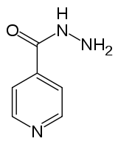**Paraldehyde toxicity aldehyde to acid**
   5. **Isoniazid (TB)/Iron toxicity Anion gap acidosis is the result of inhibition of**

**. lactic dehydrogenase enzyme that metabolizes lactic**

**. acid to pyruvate**

* 1. **Lactic acidosis**
  2. **Ethylene glycol toxicity**
  3. **Salicylate toxicity**

Calcium (8.5 – 10.5 mg/dL in serum) Albumin (3-5 g/dL) p16

1. 50% of Calcium is unbound and active
2. 40% is bound to albumin
3. 10 % complex with phosphate and citrate

If Ca and albumin levels are low use:

**Corrected Calcium = Observed. Ca + 0.8 (4 - Observed. Alb.)**

1. Cause of HyPOcalcemia
   1. Oral phosphorous b/c precipitate complex
   2. Loop diuretics low K in cell 🡪 weak pump
   3. Calcitonin opposes PTH
2. Cause of HyPERcalcemia
   1. Thiazide diuretics low Na in cell 🡪 stronger pump

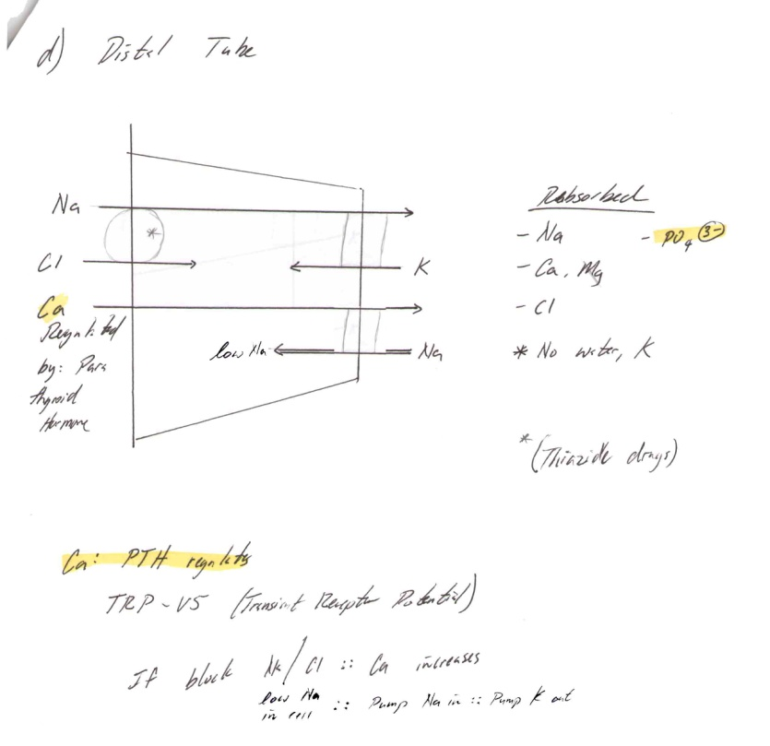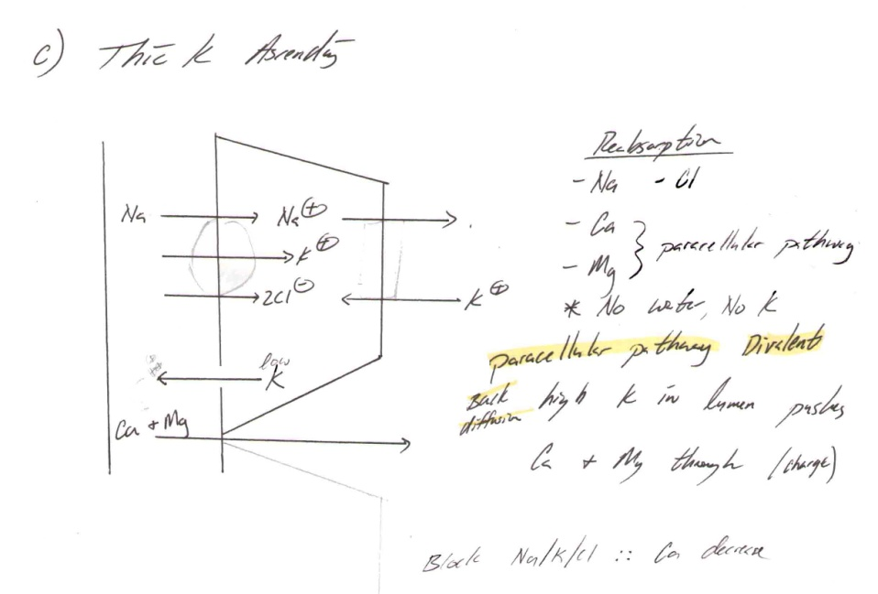

Phosphate 2.5 – 5 mg/dL

1. Cause of hyperphosphatemia
   1. Renal failure

Magnesium 1.6 – 2.4 mEq/L

Uric Acid

1. Physiology end product protein metabolism
2. Excreted by kidney Gout
3. Cause of Hyperuricemia Renal dysfunction, Thiazide diuretics

Liver Tests Enzyme Vs Function

|  |  |
| --- | --- |
| **Liver Enzyme Test: No detect disease** |  |
| Alanine Aminotransferase (ALT) acute injury | 0 – 35 units/L 30 (+-15) |
| Aspartate Aminotransferase (AST) acute injury | 5 - 35 units/L 20 (+-15) |
|  |  |
| Alkaline Phasphate (ALP) only bone & biliary obstruct | 30 – 120 units/L 70 (+-40) |
|  |  |
| Gamma-Glutamyl Transferase (GGT) drug induced & billary | 0 – 70 units/L Failure |
| Lactate Dehydrogenase (LDH) | 100 – 200 units/L |
|  |  |
| **Liver Function Test: Detect disease** |  |
| Total Bilirubin  Conjugated bilirubin billary tract disease  Unconjugated bilirubin | 0 – 1  0.2  0.8 |
| Albumin | 3.5 – 5 g/dL |

Liver Test: Liver Enzyme Test

Increases after  heart or [liver](http://www.webmd.com/digestive-disorders/picture-of-the-liver)  diseased or damage

1. Alanine Aminotransferase (ALT) enzyme increases after ACUTE injury
2. Aspartate Aminotransferase (AST) Release after cell damage
3. Alkaline Phosphate (ALP) highest concentration in bone and liver
   1. Use: removes phosphate
   2. Cause in increase when billary obstruction (cholestasis)
4. Gamma-Glutamyl Transferase (GGT) body tries to remove DRUGS
   1. Cause an increase when drug induced
5. Lactate dehydrogenase

Liver Function Test

1. Bilirubin

|  |  |  |  |
| --- | --- | --- | --- |
| **Type** | **Synonym** | **Source** | **Diagnosis** |
| Unconjugated | Indirect | Breakdown product of  hemoglobin formed in the RES | Excessive production – hemolysis  Immature enzyme system – neonatal jaundice  Intrahepatic Liver disease |
| Conjugated | Direct | Bilirubin is metabolized in the liver to conjugated bilirubin (bilirubin di glucuronide) | Cholestatic Disease. Biliary tract disease |
| Note: Both conjugated and unconjugated may be elevated in hepatitis | | | |

1. Albumin (3.5 – 5 g/dL)
   1. Use measure osmotic pressure of blood
   2. Low albumin b/c hepatic disease

|  |  |
| --- | --- |
| Hemoglobin  Male  female | 13.5-17.5 g/dl 15 (+-2)  11.5-15.5 g/dl 13 (+-2) |
| Erythrocytes | 4.5 – 5.9 * 10^6 cells/mm^3 |
|  |  |
| WBC (Leukocyte) | 4500 – 11,000 cells/mm^3 |
| Neutrophils (Segs) | 2000 neutrohphils/mm^3  55 – 60% of WBC 60 ( +-5) |
| Bands | 3 – 5% of WBC 4 (+-1) |
| Lymphocytes | 25 – 33% of WBC 30 (+-5) Viral |
| Eosinophils | 1 – 3% of WBC 2 (+-1) Allergy & parasite |
|  |  |
| Platelets | 150,000-450,000 |

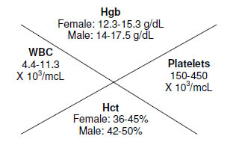Hematology and **Coagulation** Tests

WBC

Hct

Hgb

Platelets

RBC Test: Anemia

* + 1. Hemoglobin (Hgb)
  1. Male 13.5-17.5 g/dl
  2. Female 11.5-15.5 g/dl

1. Hematocrit Hematocrit is 3X more than Hemoglobin
   1. Male 39-50%
   2. Female 33-45%
      1. Reticulocytes: immature RBC 0.5% - 2%
      2. Erythrocytes: mature RBC 4.5 – 5.9 * 10^6 cells/mm^3
   3. Life span: 120 days
      1. Red blood cell (Wintrobe) indices
2. Mean Corpuscular Volume
   1. measures: RBC size small size = anemia (not fully grown)
3. MCH concentration
   1. Measures: amount

WBC (leukocyte) Composition

* + - 1. Absolute Neutrophil Count (ANC)
         1. Normal neutrophil count 1000 – 2000 neutrophils/mm^3
         2. Infection < 500 neutrophils/mm^3
      2. 55-60 % Neutrophils (Segs) mature WBC
      3. 3 - 5 % bands immature WBC shift to the left (primitive)
      4. 25 – 35% Lymphocytes increased due to Viral Infection
      5. 1 – 3% Eosinophils increased due to Allergy & parasite

Platelets 150,000-450,000

Thrombocytosis increased platelets

Thrombocytopenia decreased platelets